# Reading List Notes

## Enhancing upper limb mobility through gamified tasks and Azure Kinect: a preliminary study in post-stroke subjects

Study mentions that it is useful to be able to see the avatar moving as the patient moves.

Movements include lateral movements and frontal movements. It is said that patients struggle the most with lateral movements.

The game developed is a gym simulation.

The following body segments were considered: upper limb segment between the wrist and clavicle joints (UPPL); trunk segment between the neck and pelvis joints (TRUNK); arm segment between the clavicle and elbow joints (ARM); and forearm segment between the elbow and wrist joints (FORE)

Some patients preferred to play the game sitting

Upper limb improvements saw an increase in the movement speed and repetitions per minute.

This was a clinical trial which used post stroke patients and reported overall positive effects.

This study uses a camera to stream the patients movements. And there fore is limited in it cannot detect hand and wrist movements, something that etee will be able to detect.

## Virtual Reality Mirror Therapy (VRMT) to Improve Finger Dexterity in Post-stroke Survivors: A Preliminary Feasibility Study of a Home-based Intervention

Partnered with etee to create a VMRT system.

Study was done on post stroke adults

Study focused on clinical improvements as well as motivation.

Also recorded promising adherence rates.

Due to a sample size the study could only conclude that the system gives promising results.

It did find that post stroke participants were able to use etee with no adverse effects.

System does appear to be motivating with participants scoring highly on value/useful subscale of the IMI.

The therapy seems to focus on the stroke effected hand

The therapy software created is shown in the study although development methodologies are not discussed. The game looks almost similar to a guitar hero style game where hands in a specific position move towards the player and the player has to match the positions of the hands.

This is a low scope game. The environment is very simple. The ui is simple and clear and the gameplay is focused.

## Effectiveness of a Gamified and Home-Based Approach for Upper-limb Rehabilitation

62 patients over a 14 month period with an average of 16 sessions completed per patient.

All patients improved their pain level with an overall 73.3% average pain reduction. In terms of treatment satisfaction 95% of patients would recommend the proposed solution to friends of family.

Main benefits reported: convenience, time, flexibility and customization.

Telerehabilitation system studied, patients exercise within a digital game-like experience, their motion is tracked using a sensorless paradigm.

Study agrees that serios games improve motor limb, movement, and balance when compared to conventional rehabilitation techniques.

Motiphy+ is the game they study in this literature.

Composed of a: (1) Web-based backend, Physiotherapist portal to remotely prescribe exercises and follow patient progress depth camera to track the body.

This software had a high scope. The game had to interface with the depth camera and track the body. Addiditonally the software had many different exercises the patient could chose. The actual exercises seem to be quite simple to create however.

Of the screenshots shown lateral arm movement is promoted. In the application of my study the etee are only going to be used to track rotation. Which makes tracking lateral arm movement difficult. One useful exercise to target shoulder muscles used In lateral arm movement would be to track the yaw rotation of the controllers when the patients arms are pointing down. The patient could start with their arm to their side with their hand suinated. Then in order to turn their hand 360 degrees they may have to move their arm to the other side of their body while rotating their wrist. This will produce wrist movement and will put their shoulder muscle into a deep stretch which would be beneficial.

Patients performed an average of 3 sessions per week. After completion 85.5% of patients were considered fully recovered

Satisfaction was gathered via questionanaire. 95% of patients were satisfied. And would recogmend.

This software is very useful may be worth looking into Clynx motiphy+

## Adaptive gameplay and difficulty adjustment in a gamified upper-limb rehabilitation

Seems to be an excellent very good piece of literature.

Mainly based on tackling lack of motivation. States that it is a very common problem that worsens the efficacy of rehabilitation significantly decreasing revoery rates of the patient.

Also explored gamification elements, gameplay design and adaptive difficulty.

Kinect based system.

It is clear from other studies that gamification leads to better results and is more appreciated by the patients.

As for development methodology game created in unity.

Game consists of a set of minigames. Which creates a minigame repository. The physiscician might select several mini-games from this repository creating a health plan for each specific patients rehabilitation goals.

Study focuses on how the difficulty of the game can be adaptive to ensure patients don’t get bored by the game being easy and don’t get frustrated by the game being too hard. Flow state

Difficulty implemented as a state mechine and depending on the performance of the player the game can transition from one difficulty state to another. Easy medium and hard.

Minigames focused on: Abstract Masterpeice, Boat sailing, classic clock and butterflies.

Abstract Masterpeice: patient moves upper limb to hit paintball infront of them firing it towards a canvas to make a painting. Difficulty is how high up the ball spawns

Boat Sailing: boat controlled with forearm

Classic clock: player must mimic the motion of a clock pendulum. Difficultu is how high up their arm must go

Butterflies: player must reach upper arm to touch butterflies resting on a rock

There is a database for the health professional to access

When reviewing preferred setting, 243 people questioned, Nature (63.2%), Sports (59.7%), Fantastic (29.1%) and cozy (15.9%). My game will be a mix of Nature and Sports (fishing).

Gamification elements: reward for good things and inverse stimuli for bad and scoring.

Interactive elements and feedback.

## Mobile game-based virtual reality program for upper extremity stroke rehabilitation

This uses a mobile device in a arm strap harness to track the orientation of the arm.

4 games developed: Honey pot guard, protect the bunney, put out fire and flower splash

Honey pot guard focuses on extending a flexed elbow to simulate throwing

Protect the bunney – movement of shoulder joint to make arm go across body

Put out the fire – move water hose to put out fire targets shoulder

Flower splash – water a moving plant focuses on shoulder and arm movement

Estimate that Therapeutic effectiveness equal or greater because immediate freadback from patients movement, enjoyment, high motivation and engagement.

## Rehago - A Home-Based Training App Using Virtual Reality to Improve Functional Performance of Stroke Patients with Mirror Therapy and Gamification Concept: A Pilot Study

VR

Virtual mirror therapy in combo with gamified exercises

48 stroke patients

Dosage set to 30 mins per day, 5 days per week, 6 weeks.

Saw “an average improvement of 5.54 points in the Functional Independence Measurement score, and an improvement of 7.13 points in the assessed quality-of-life score” this shows that it is an effective rehabilitation tool

Study focuses on the use of rehago not the development of it.

They used the mirror mode in the software

Patients saw functional improvements after 42 days, did see an increase in patients saw an increase in independence of movement and quality of life.

It was concluded that more trials should be done on a greater sample set but this shows promise.

## Gamified in-home rehabilitation for stroke survivors: analytical review

Literature review focusing on 32 articles of which there are 28 unique therapies presented.

The review will

Identify and explain the most used features

Provide a simple way to classify these features

20 features identified

Patients willing to pay costs ranging from 300 to 1500 dollars. And there is a want to practice gamified therapies at home when insentivised and if affordable. Most solutions reviewed 92% (26 studires) were low cost solutions.

“Researchers have found that commercially available hardware designed for entertainment can be used to this end, as they are cheap and usually available in the market”

Possible snowballing paper: Towards customizable games for stroke rehabilitation

50% focused on gross arm movement and hand placement, and 36% focused on more fine movements such as hand opening and closing

Music Kirk et al found for at least cognitive rehabilitation “stroke survivors reported high of motivation to use music as part of their rehabilitation”

Meaningful play was identified as a very important characteristic. The player should be able to perceive an immediate effect of their actions. Feedback very important.

Social interaction is “considered as the most important motivational aspect to be implemented in a rehabilitation system” (page 10)

Players can cooperate or compete amonth themselves. Competition being a strong conduct. Social interaction means that patients can share yheir prpogress with family, friends or other patients.

Simplest implementation is sharing the patients score and progress with other players. Featured in the REWIRE project.

Only 7% of total works have implemented social interaction. Meaning this is somewhat of a frontier.

Variety counts

Hung et al. [21] introduced that 84% of the therapists agreed that if a gameplay is similar to a prior game experience of the patients, the familiarity with the game is thought to positively influence the patient’s motivation for rehabilitation.

Difficulty can be a very good motivator but when used incorrectly can also be very demotivating. Adequate challenge should be provided to the player as without it the game will be boring.

This can be easily implemented as a difficulty selection easy, medium and hard. Or other means of difficulty selection could be used.

46% of studies had difficulty in the menus while 18% adjusted automatically.

One limitation frequently daced is the interaction devices. Particularly for older patients this is important. The interaction devices must not be complex. Wearable devices like electromagnetic sensors, data gloves and HDMs have the drawback of needing to be attached or fixed to the user. etee wont have this issue.

To address these issues normally solutions like depth cameras or other vision based systems are used.

Motivational rewards. Such as points and rankings are a good way of generating motivations. Motivational rewards in conjunction with being able to share these features with others can generate addiction.

Besides a point system the rehab games don’t seem to implement many motivational rewards systems. May be worth looking into other forms of meta game progression.

Breaks games down into the following feature groups:

Rehabilitation focused, adoption focused, motivation focused and monitoring focused

Motivation focused rehabs should focus on variety, quality of interaction, familiarity, focus and mode of interaction

## Serious gaming technology in upper extremity rehabilitation: scoping review

First use if gamification in upper limb rehavilitation was 1999 by a team at Rtgers unitverdity. This was done using robotic arm.

Research goals: Explore the technologies used for UL rehav, discover distinct methids and common characteristics and objectives of these efforts. (3_ identify challenges and limitations

Researchers prefer to use commercial hardware over development of new hardware.

Most games developed were vr (not necessarily immersive) 74.6%

The game target was normally target task completion 62.1% but was also score based 41.1%

Means of evaluation consist of feedback from users or therapists about user experience.

Sometimes the studies used range of movement as a metric

## Compliance with Upper Limb Home-Based Exergaming Interventions for Stroke Patients: A Narrative Review

People people do not feel motivated to engage in new habits. This includes exercise. The main reason for non adherence is due to limited motivation.

There is no consensus on the optimum amount, intensity, distribution or duration of therapy. That’s to say the therapy should be able to adapt to its user.

The key elements of task specific training are, repeated challenging practice of functional goal oriented activities.

Overall dose ranged from 20 mins to 120 mins per day.

More than 20 mins and no more than 90 min seems to be the dosage most studies used

Some studies used a familirization stage to allow the user to get to grips with the device before home use.

“There are 4 essential areas in the development of compliant behaviour: perceived susceptibility; perceived severity; perceived benefits; and perceived barriers.” Page 6

## Towards Customizable Games for Stroke Rehabilitation

Only 31% of patients perform the exercises recommended by their therapists.

Recogmended hundreds of repetitons per day. This is why gamification is good to reduce the monotomy.

It is recommended that stroke rehabilitation utilizes high intensity repetitive motions with explicit feedback.

Iterative design process to build and user test games.

Movements:  
  
These are the building blocks used to create the games

Multiplayer ganes give more motivation, also references competitive or collaborative. They created a computer player for some of the multiplayer games, so patients are able to play with a virtual companion.

Can be focused on a single motion such as elbow flexion, or can require a combination of multiple muscles such as reaching.

Split input into 1D vertical and horizontal inputs (simple muscle motions) and 2D inputs for purposeful and coordinated motions.

Games Created:

* Frog Simon
  + Single player, 2D input, challenge on memory.
* Dirt Race
  + Two player collaborative, basic 1d input. Setting is a truck driving through a locust swarm, one player has to hand operate a windshield wiper (moving arm left and right) and the other player steers the car. One patient played for 15 mins.
* Baseball catch
  + Single Player
* Catch the kitty
  + Two player competitive game. Two player competitive game, horizontal 1d input. Animals fall from above players move horizontally to catch pet. Animals are assigned colours for each player. Players try to score higher then each other
* Under the sea
  + Two player collaborative game, vertical 1d input. One player with 2d input controls fish with babies trailing behind and must collect ferns to get points. There is an enemy fish which goes from left to right. Stroke patient must control a snail to move up and down the screen to block and protect the player fish. This was popular players played for 25 mins
* Pong
  + Two player competitive game 1d vertical input, ball speed each was as well as paddle size and ball size can be customised in difficulty settings. Also cooperative rally one central score both players work towards. Players liked the collaborative mode quite a lot. 20 mins avg playtime
* Frogger
  + Collaborative one player controls 1d to go forwards and the other player has 1d control to move sidewards. Other than that normal frogger. Avg playtime 15 mins
* Helicopter
  + Single Player
* Garden
  + Single Player

Some lessons learned are. Assume no use of hands. Most of the patients they tested on had very little control of their fingers.

Simple games should support multiple methods of user input. The patient may start off not using their hands but later on as they get more voluntary control of their hands it may become useful for the game to be vontrolled with hand gestures. The games should be designed / created to accommodate for this.

Important to be able to calibrate range of motion per patient.

Greatest value is movements which cover the full range of motion.

Making games fun and challenging. Audio and visuals important, difficulty considered and there is the ability to adjust the difficulty.

One patient in the study usually had an isolated lifestyle, however when playing one of the games began to talk about potentially playing games with her grandson as a way of furthering her connection with him.

The multiplayer games can provide a context where a patient and their carer are able to collaborate as equals. Rather than the norm in which the patient is dependent on their caregiver.

## An integrated low-cost system for at-home rehabilitation

Considered the principle of meaningful play

Virtual community of patients, caregivers and clinicians involved in the rehabilitation process. Patiens can share their experiences and information with other patients and with therapists. This fosters a strong and suppourtive community

## Improving the Motivation and Participation of Elderly Patients in Rehabilitation Program Through Social Games

Competitive gameplay can increase motivation and excersise intensity.

“Therefore, this study aims to incorporate competition within game design and investigate its effects on patient motivation, participation and functional improvements through a long-term in-situ study.”

Developed a single player game, a competitive game and a control group (conventional training). Quantitive and qualitive used.

Results

Player enjoyment significantly decreased over 12 weeks. Slightly more than the control group.

However the group playing the competitive game exhibited sustained player enjoyment.

Both game groups reported slightly higher excersise duration and when compared with the control group significantly higher improvements were found in both game groups with the dominant hand.

Therefore overall competivie gameplauy has significant effects on long-term motivation and intrest.

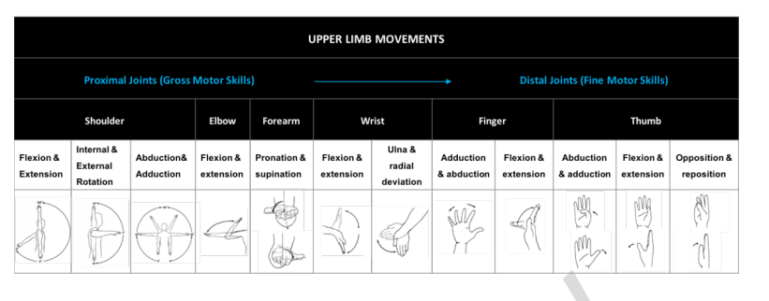However there was challenges such as patients losing games, cheating and balancing the game around the patients abilities which may be limited.

Common movements identified

Splits movements up into gross and fine. Training starts with gross movements (shoulder elbow) and then moves onto fine motor movements.

“While Souders, Boot, Charness, & Moxley (2016) found that peer-playing increased enjoyment among older adults, Nap, Kort, & Ijsselsteijn (2009) reported that peerplaying over the internet decreased satisfaction” – page 22

“The social interaction in games is normally in the form of two-player competitive gameplay or two-player cooperative gameplay. Cooperation refers to the situation in which two or more players play together to complete the same task to attain the same goal. Competition involves two or more players competing in the same game task. Both competition and cooperation are identified as the main sources of player motivation as they can promote social relationships between players (Malone & Lepper, 1987).” – page 22

Studies (Staiano, Abraham, & Calvert, 2012), (Lin, Mamykina, Lindtner, Delajoux, & Strub, 2006), (Chin A Paw, Jacobs, Vaessen, Titze, & van Mechelen, 2008), all reported that games with social interaction result in higher motivation and energy expenditure, (Staiano et al., 2012), which stimulates participants to excersise longer and can lead to higher adherence rates than single player games (Chin A Paw et al., 2008).

## 4.5.5.1.5 Evaluating the Impact of Player Experience in the Design of a Serious Game for Upper Extremity Stroke Rehabilitation

Individuals inder medical supervision do not always follow their supervision.

In the game designed there is the ability for the game to be played in a single player or multi player mode. Multiplayer gives the option of competitive and collaborative.

Not significant differences in immersion between single player and multiplayer.

Average tension higher in single player than multiplayer. Tension being defined as the user feeling tense, annoyed, irritable or frustrated.

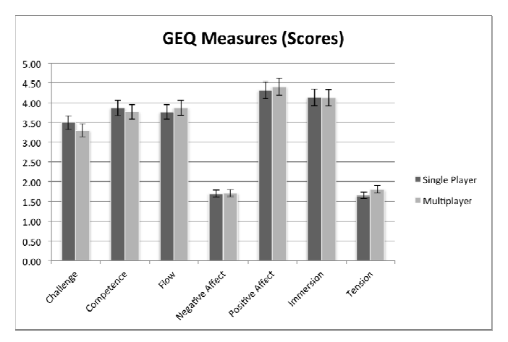

Expected multiplayer to be more motivation however no significant differences were found between single player and multiplayer mode.

dicussion

Introducing characters into the game would have given the players more to interact with. This would have raised immersion.

Players felt more distracted in the single player mode

Results indicated that engagement were somewhat higher in multiplayer mode (collaborative\0 than in single plauer mode.

## Exoskeletons with virtual reality, augmented reality, and gamification for stroke patients' rehabilitation: systematic review

## Analysis, Design and Implementation of Serious Game for Upper Limb and Cognitive Training Using Leap Motion for Multiple Sclerosis Patients

## Mirror VR: The design of a fully immersive virtual reality game for upper limb rehabilitation post-stroke using mirror therapy

## Enabling Home Rehabilitation with Smartphone-Powered Upper Limb Training

## Virtual reality exergames for enhancing engagement in stroke rehabilitation: A narrative review

## Trends in robot-assisted and virtual reality-assisted neuromuscular therapy: a systematic review of health-related multiplayer games

## Serious games for stroke telerehabilitation of upper limb-a review for future research

## Improving the Motivation and Participation of Elderly Patients in Rehabilitation Program Through Social Games

## Serious games for upper limb rehabilitation after stroke: a meta-analysis

## Development of a 3D, networked multi user virtual reality environment for home therapy after stroke

## Serious Game Design and Clinical Improvement in Physical Rehabilitation: Systematic Review

## Virtual reality games for rehabilitation of upper extremities in stroke patients. Journal of bodywork and movement therapies

## Personalised physiotherapy rehabilitation using artificial intelligence and virtual reality gaming

## A Review on Serious Games for Exercise Rehabilitation

## Evaluating the impact of player experience in the design of a serious game for upper extremity stroke rehabilitation